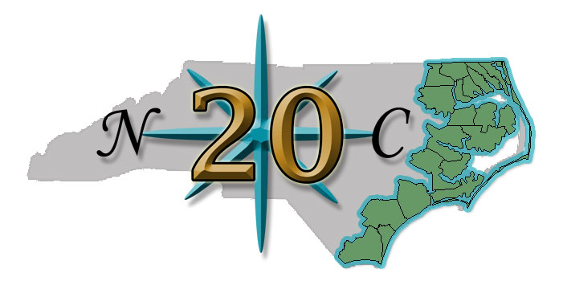

NC 20 Response to Latest Rate Filing
By Willo Kelly, President

NC Department of Insurance Commissioner Wayne Goodwin had alerted us a few months ago that the NC Rate Bureau would be filing a Property Insurance Rate Filing before the General Election. In speaking with Commissioner Goodwin by phone earlier today, he informed me that he was notified of the filing around 6 pm last night.

The NC DOI has 45 days to respond to the filing - either approve, call for Public Hearing or negotiate rates with the NC Rate Bureau as former NC Insurance Commissioner Jim Long did for years. Legislation passed earlier this year mandates that the Commissioner call a public comment period on any NC Rate Bureau Rate Filing. Goodwin did call for public comment on the Dwelling Rate Filing submitted last year and subsequently called for a Public Hearing on the filing. After the lengthy public hearing process, Goodwin utlimately denied proposed extended coverage (wind and hail) increases and approved fire coverage decreases statewide.
If NC DOI agrees with this Rate Filing, the below filed rates will go into effect June 1, 2013.

This 1,267 page Homeowners Insurance Rate Filing represents a 30% rate increase for Homeowners Insurance in all 18 eastern NC counties that are in the NCIUA (Beach Plan) coverage area.
The rate is the maximum amount a company may charge for coverage unless a policyholder signs a "consent to rate" form allowing an insurance company to charge a higher than NCDOI approved amount.
The Rate Filing differs from the last Homeowners Insurance Rate Filing of 2008 in that proposed rates are based on $75,000 of coverage instead of $150,000 of coverage. The Rate Filing also includes proposed rate increases of 30% statewide for renters coverage and a 30% increase in condo coverage for the majority of the state. Below is the impact of the rate filing on eastern NC based on $75,00 of coverage:

Territory 7 - Currituck, Dare and Hyde - Barrier Islands Homeowners Current rate per $75,00 of coverage: $1,379 - Filed: $1,793 ; an increase of $414

Territory 8 - Brunswick, Carteret, New Hanover, Onslow, Pender - Coastal Areas Homeowners Current rate per $75,000 of coverage: $1,522 - Filed: $1,979; an increase of $457

Territory 48 - Currituck, Dare, Hyde, Pamlico - mainland areas Homeowners Current rate per $75,000 of coverage: $987 - Filed: $1,283; an increase of $296

Territory 49 - Beaufort, Camden, Chowan, Craven, Jones, Pasquotank, Perquimans, Tyrrell, Washington Homeowners Current rate per $75,000 of coverage: $862 - Filed: $1,121; an increase of $259

Territory 52 - Brunswick, Carteret, New Hanover, Onslow, Pender - mainland areas Homeowners Current rate per $75,000 of coverage: $1050 - Filed: $1,365; an increase of $315

Overall, the Rate Filing represents an average 17.7% statewide property insurance rate increase with the highest requested rate increase of 30% in eastern NC. By comparison, the Winston-Salem/Greensboro territory has the lowest proposed rate increase of 1.2% representing a rate change from $365 to $369 for $75,000 worth of coverage.

The last NC Rate Bureau Homeowners Insurance Rate Filing was approved in December 2008 by former Insurance Jim Long. The negotiated rates went into effect May 1, 2009.
Research from that NC Rate Bureau Rate Filing uncovered that 32 NC Counties and the City of Charlotte are currently paying equal or less in Homeowners Insurance "rate" than they did in 1993. The rate in place in 1993 for the City of Charlotte was $351 per $75,000 of coverage. The current rate for Charlotte is $344; the NC Rate Bureau is requesting a rate increase of 8.5% for the Charlotte territory. This proposed increase would essentially add $29 in premium for $75,000 of coverage.

The October 1, 2012 Rate Filing can be found in its entirety here:
http://www.ncrb.org/ncrb/Portals/0/ncrb/personal%20lines%20services/Rate%20Filings/2012%20Homeowners%20Rate%20Filing.pdf

NC Department of Insurance Commissioner Wayne Goodwin had alerted us a few months ago that the NC Rate Bureau would be filing a Property Insurance Rate Filing before the General Election. In speaking with Commissioner Goodwin by phone earlier today, he informed me that he was notified of the filing around 6 pm last night.

The NC DOI has 45 days to respond to the filing - either approve, call for Public Hearing or negotiate rates with the NC Rate Bureau as former NC Insurance Commissioner Jim Long did for years. Legislation passed earlier this year mandates that the Commissioner call a public comment period on any NC Rate Bureau Rate Filing. Goodwin did call for public comment on the Dwelling Rate Filing submitted last year and subsequently called for a Public Hearing on the filing. After the lengthy public hearing process, Goodwin utlimately denied proposed extended coverage (wind and hail) increases and approved fire coverage decreases statewide.
If NC DOI agrees with this Rate Filing, the below filed rates will go into effect June 1, 2013.

This 1,267 page Homeowners Insurance Rate Filing represents a 30% rate increase for Homeowners Insurance in all 18 eastern NC counties that are in the NCIUA (Beach Plan) coverage area.
The rate is the maximum amount a company may charge for coverage unless a policyholder signs a "consent to rate" form allowing an insurance company to charge a higher than NCDOI approved amount.
The Rate Filing differs from the last Homeowners Insurance Rate Filing of 2008 in that proposed rates are based on $75,000 of coverage instead of $150,000 of coverage. The Rate Filing also includes proposed rate increases of 30% statewide for renters coverage and a 30% increase in condo coverage for the majority of the state. Below is the impact of the rate filing on eastern NC based on $75,00 of coverage:

Territory 7 - Currituck, Dare and Hyde - Barrier Islands Homeowners Current rate per $75,00 of coverage: $1,379 - Filed: $1,793 ; an increase of $414

Territory 8 - Brunswick, Carteret, New Hanover, Onslow, Pender - Coastal Areas Homeowners Current rate per $75,000 of coverage: $1,522 - Filed: $1,979; an increase of $457

Territory 48 - Currituck, Dare, Hyde, Pamlico - mainland areas Homeowners Current rate per $75,000 of coverage: $987 - Filed: $1,283; an increase of $296

Territory 49 - Beaufort, Camden, Chowan, Craven, Jones, Pasquotank, Perquimans, Tyrrell, Washington Homeowners Current rate per $75,000 of coverage: $862 - Filed: $1,121; an increase of $259

Territory 52 - Brunswick, Carteret, New Hanover, Onslow, Pender - mainland areas Homeowners Current rate per $75,000 of coverage: $1050 - Filed: $1,365; an increase of $315

Overall, the Rate Filing represents an average 17.7% statewide property insurance rate increase with the highest requested rate increase of 30% in eastern NC. By comparison, the Winston-Salem/Greensboro territory has the lowest proposed rate increase of 1.2% representing a rate change from $365 to $369 for $75,000 worth of coverage.

The last NC Rate Bureau Homeowners Insurance Rate Filing was approved in December 2008 by former Insurance Jim Long. The negotiated rates went into effect May 1, 2009.
Research from that NC Rate Bureau Rate Filing uncovered that 32 NC Counties and the City of Charlotte are currently paying equal or less in Homeowners Insurance "rate" than they did in 1993. The rate in place in 1993 for the City of Charlotte was $351 per $75,000 of coverage. The current rate for Charlotte is $344; the NC Rate Bureau is requesting a rate increase of 8.5% for the Charlotte territory. This proposed increase would essentially add $29 in premium for $75,000 of coverage.

The October 1, 2012 Rate Filing can be found in its entirety here:
http://www.ncrb.org/ncrb/Portals/0/ncrb/personal%20lines%20services/Rate%20Filings/2012%20Homeowners%20Rate%20Filing.pdf

